**Microservices with Spring Boot 3 and Spring Cloud**

**Creating Microservices for account and loan**

**Account**

**Controller 🡪 AccountController.java**

package com.cognizant.account.controller;  
  
import org.springframework.web.bind.annotation.*;  
  
@RestController  
@RequestMapping("/accounts")  
public class AccountController {  
  
 @GetMapping("/{number}")  
 public Account getAccount(@PathVariable String number) {  
 return new Account(number, "savings", 234343);  
 }  
}  
  
class Account {  
 private String number;  
 private String type;  
 private double balance;  
  
 public Account(String number, String type, double balance) {  
 this.number = number;  
 this.type = type;  
 this.balance = balance;  
 }  
  
 public String getNumber() { return number; }  
 public String getType() { return type; }  
 public double getBalance() { return balance; }  
}

**AccountApplication.java**

package com.cognizant.account;  
  
import org.springframework.boot.SpringApplication;  
import org.springframework.boot.autoconfigure.SpringBootApplication;  
  
@SpringBootApplication  
public class AccountApplication {  
  
 public static void main(String[] args) {  
 SpringApplication.*run*(AccountApplication.class, args);  
 }  
  
}

**OUTPUT:**

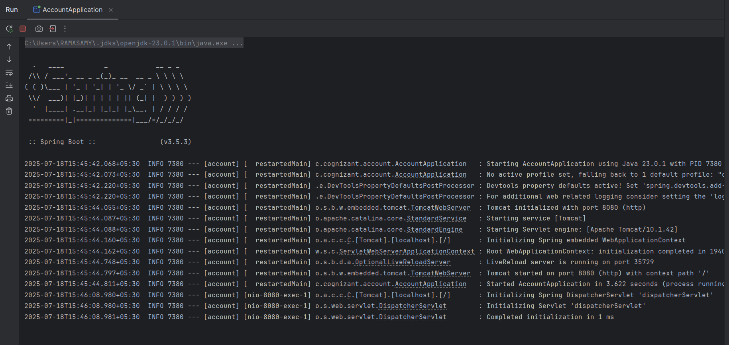

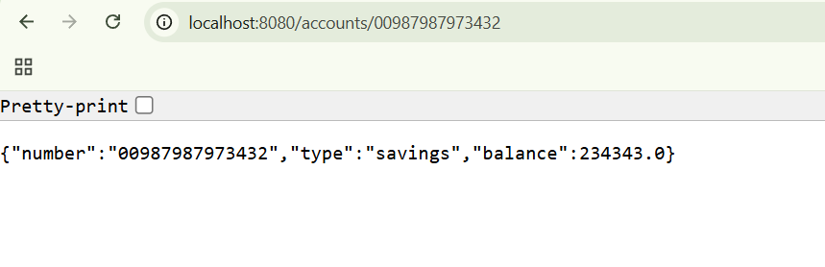

**Loan**

**Controller 🡪 LoanController.java**

package com.cognizant.loan.controller;  
  
import org.springframework.web.bind.annotation.*;  
  
@RestController  
@RequestMapping("/loans")  
public class LoanController {  
  
 @GetMapping("/{number}")  
 public Loan getLoan(@PathVariable String number) {  
 return new Loan(number, "car", 400000, 3258, 18);  
 }  
}  
  
class Loan {  
 private String number;  
 private String type;  
 private int loan;  
 private int emi;  
 private int tenure;  
  
 public Loan(String number, String type, int loan, int emi, int tenure) {  
 this.number = number;  
 this.type = type;  
 this.loan = loan;  
 this.emi = emi;  
 this.tenure = tenure;  
 }  
  
 public String getNumber() { return number; }  
 public String getType() { return type; }  
 public int getLoan() { return loan; }  
 public int getEmi() { return emi; }  
 public int getTenure() { return tenure; }  
}

**LoanApplication.java**

package com.cognizant.loan;  
  
import org.springframework.boot.SpringApplication;  
import org.springframework.boot.autoconfigure.SpringBootApplication;  
  
@SpringBootApplication  
public class LoanApplication {  
  
 public static void main(String[] args) {  
 SpringApplication.*run*(LoanApplication.class, args);  
 }  
  
}

**OUTPUT:**